SPRINT 1

|  |  |
| --- | --- |
| Date | 9 november 2022 |
| Team ID | PNT2022TMID00982 |
| Project Name | Project – Signs with Smart Connectivity for Better Road Safety |

SPRINT GOALS:

1. Create and initialize accounts in various public APIs like OpenWeather API.
2. Write a Python program that outputs results given the inputs like weather and location.

**CODE FLOW:**

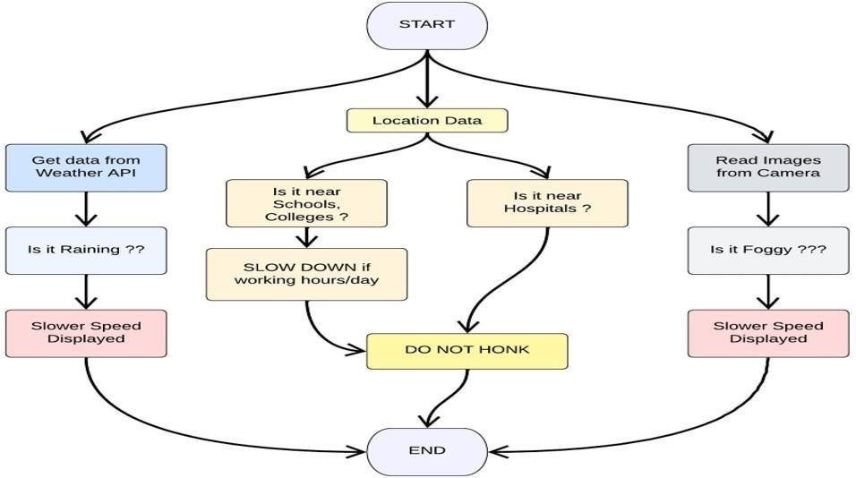

PROGRAM CODE:

Weather.py

This file is a utility function that fetches the weather from

OpenWeatherAPI. Itreturns only certain required parameters of the API response.

# Python code import requests as reqs def

get(myLocation,APIKE

Y):apiURL = f"https://api.openweathermap.org/data/2.5/weather?q={myLocation}&appi d={API KEY}"

responseJSON =

(reqs.get(apiURL)).json() returnObject = {

"temperature" : responseJSON['main']['temp'] - 273.15,

"weather" : [responseJSON['weather'][_]['main'].lower() for _ in range(len(responseJSON['weather']))],

"visibility" : responseJSON['visibility']/100, # visibility in percentage where10km is 100% and 0km is 0%

}

if("rain" in responseJSON):

returnObject["rain"] = [responseJSON["rain"][key]

for key inresponseJSON["rain"]]

return(returnObject

brain.py

This file is a utility function that returns only essential information to be displayed at the hardware side and abstracts all the unnecessary details. This is where the code flow logic is implemented.

# Python code

# IMPORT SECTION STARTS import weather

from datetime import datetime as dt

# IMPORT SECTION ENDS

#

# UTILITY LOGIC SECTION STARTS def processConditions(myLocation,APIKEY,localityInfo):

weatherData = weather.get(myLocation,APIKEY)

finalSpeed = localityInfo["usualSpeedLimit"] if "rain" not in weatherData else

localityInfo["usualSpeedLimit"]/2 finalSpeed = finalSpeed if weatherData["visibility"]>35 else finalSpeed/2

if(localityInfo["hospitalsNearby"]):

# hospital zone doNotHonk = True else:

if(localityInfo["schools"]["schoolZone"]==False):

# neither school nor hospital zone

doNotHonk = False else:

# school zone

now = [dt.now().hour,dt.now().minute] activeTime = [list(map(int,_.split(":"))) for _ in

localityInfo["schools"]["activeTime"]] doNotHonk = activeTime[0][0]<=now[0]<=activeTime[1][0] and

activeTime[0][1]<=now[1]<=activeTime[1][1]

return({

"speed" : finalSpeed,

"doNotHonk" : doNotHonk

})

# UTILITY LOGIC SECTION ENDS

Main.py

The code that runs in a forever loop in the microcontroller. This calls all the util functions from other python files and based on the return value transduces changes in the output hardware display.

# Python code

# IMPORT SECTION STARTS

import brain

# IMPORT SECTION ENDS

#

# USER INPUT SECTION STARTS

myLocation = "Chennai,IN"

APIKEY = "bf4a8d480ee05c00952bf65b78ae826b"

localityInfo = {

"schools" : {

"schoolZone" : True,

"activeTime" : ["7:00","17:30"] # schools active from 7 AM till 5:30 PM

},

"hospitalsNearby" : False,

"usualSpeedLimit" : 40 # in km/hr

}

# USER INPUT SECTION ENDS

#

# MICRO-CONTROLLER CODE STARTS

print(brain.processConditions(myLocation,APIKEY,localityInfo))

'''

MICRO CONTROLLER CODE WILL BE ADDED IN SPRINT 2 AS PER OUR PLANNED SPRINT SCHEDULE

'''

# MICRO-CONTROLLER CODE ENDS

OUTPUT:

# Code Output

{'speed': 40, 'doNotHonk': False}

IMAGES:

